**Facial Recognition System**

Terminology used in face recognition

**Face verification vs face recognition**

In face verification you are given an input image as well as a name or ID of the person and the job of the system is to whether or not the input image is that of a claimed person. This is a 1:1 problem where we just want to know if the person is the person they claim to be.

The recognition problem is much harder than the verification problem. Let’s say you have a verification system that is 99 percent accurate. Suppose k = 100 in a recognition system. If you apply this system to a recognition task with a 100 people in your database, you now have 100 time chance of making the mistake. The chance of making mistake is 1%. So if you have a database of 100 persons and you need a accepted recognition error system you need a system with maybe 99.9 oe even higher accuracy before you can run it on a database of 100 persons that have a high chance of getting incorrect.

**One shot learning**

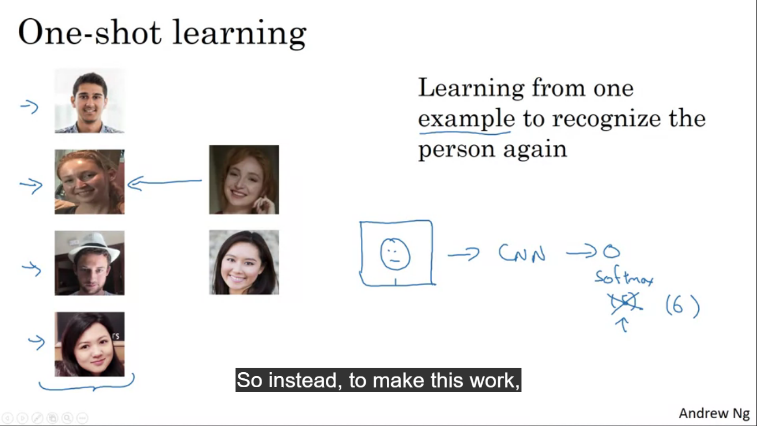

For most face recognition algorithms you need to recognize the person given just one single image of the person’s face. Deep learning algorithms don’t work well if you only have one training example.

Suppose the system has four images of a person, now if a person named Danielle showed up we want the system to recognise that this person is actually the same person as seen previously. In contrast if it sees someone not in this database then it should recognise it is not any of the four persons in the database.

In the one shot learning problem you have to learn from one example to recognize the person again. We need this because we might have only one picture of each of the team members in employee database.

One approach to try is to input the image of a person, feed it to conv net and have it output a label Y using a softmax unit with four/five outputs corresponding to the number of persons. This is not enough data to train a robust NN for this task. If another person joins the system, then we need to increase the softmax output and retrain the network, making it not a good approach.

So instead we learn a similarity function

**D(img1,img2) = degree of difference between two images.**

If the two images are of the same person we want this to output to be a small number and if two images are of two very different people a large number should output. So if the degree of similarity is <= hyper parameter tau then predict that the images are of the same person and if > tau you would say these are different persons.

To work it out the d value for each image in training is calculated, the smallest is then output as the class and if the person is the one not in the database then it will output large value for every image.

**Siamese Network**

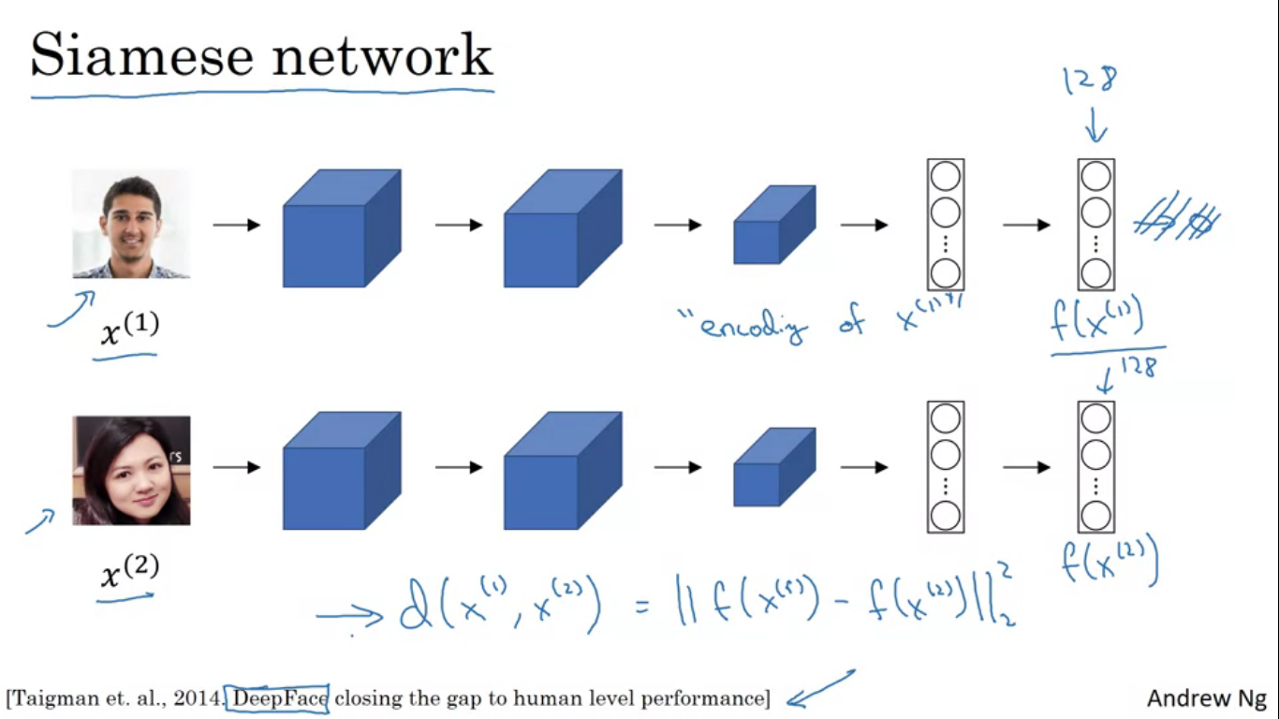

The job of the function d is to input two faces and tell you how similar or different they are. A good way to do this is to use a Siamese network. We input a vector and pass it through a set of convolution and pooling layers and FC layers to get a flattened layer. Let’s say 128 numbers computed by some fully connected layers deeper in the network. We call this list of 128 numbers a name f(x1). F(x1) is the encoding of the input image x1. So for the input image is re represented as a vector of 128 numbers. If we want to compare the two pictures we feed in the second image to the same network with the same parameters and get a different vector of 128 numbers known as f(x2). X1 and x2 are the two input images. We can then define d(x1,x2) as the norm of the difference between the encodings of these two images.

This is called a Siamese NN. These two NN have the same parameters. What we want to do is that train the NN so that the encoding it computes result in a function d that tells when two pictures are of the same person.

**Triplet Loss**

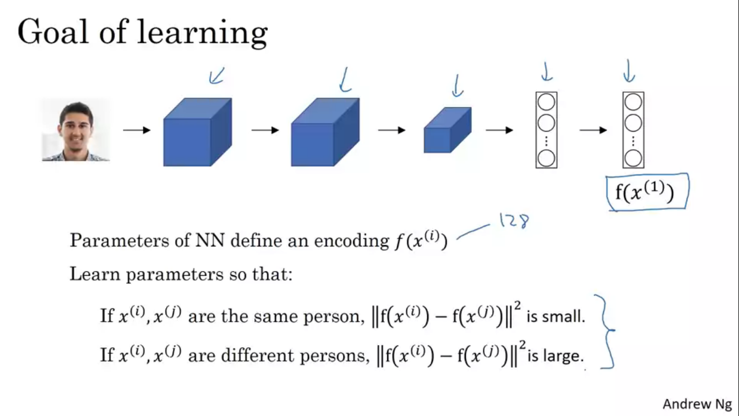

One way to learn the parameters of the NN so that it gives you a good encoding for your pictures of faces is to define and apply gradient descent on the triplet loss function.

To apply the triplet loss you need to compare the pairs of images to learn the parameters of NN you have to look at the several pictures at the same time. Given the two images as shown we want the encodings to be similar because these are of the same person. For different images we want encodings to be different.

In the terminology of triplet loss, we always look at one anchor image and then we want the distance between anchor and positive image, positive meaning same person to be similar. And we want the anchor and the negative example different person their distances to be much further apart. This gives rise to triplet loss which is that you’ll always be looking at three images at a time. You’ll be looking at an anchor image a positive image as well as a negative image.

We want the parameters of our NN to have the following property as shown in the image. By saying f(image) = vector of all 0 we can trivially satisfy this equation. To make sure the NN doesn’t make all the encodings equal to each other. Another case to get a trivial is if the encoding of every image is equal to the encoding of every other image. So we modify the objective by setting it to be quite a bit smaller than zero. So if we define the objective to be less than –alpha where alpha is another hyper parameter this prevents the network from outputting the trivial solutions. alpha is also called a margin. The margin parameter pushes the anchor positive pair and the anchor negative pair further away from each other. The most important equation is in the box.

**Loss function**

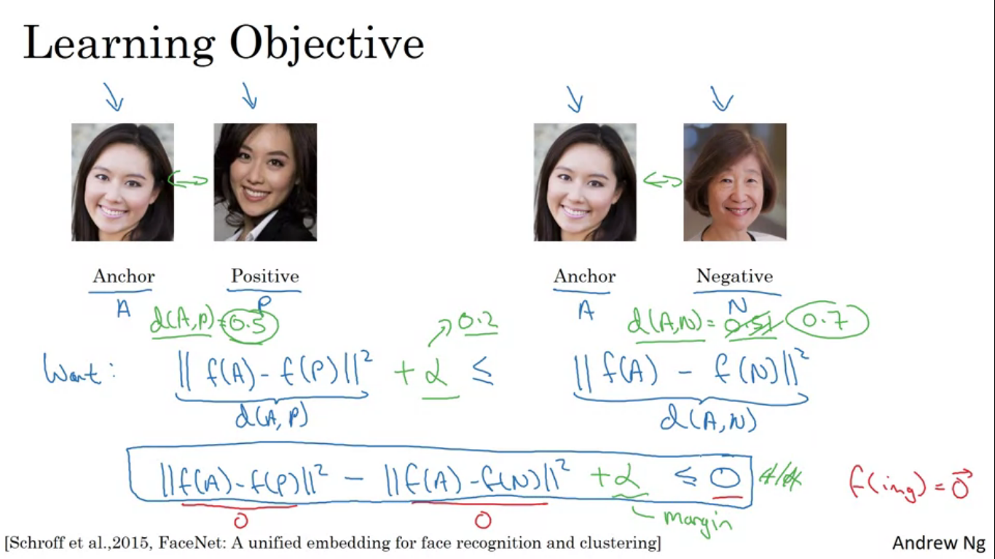

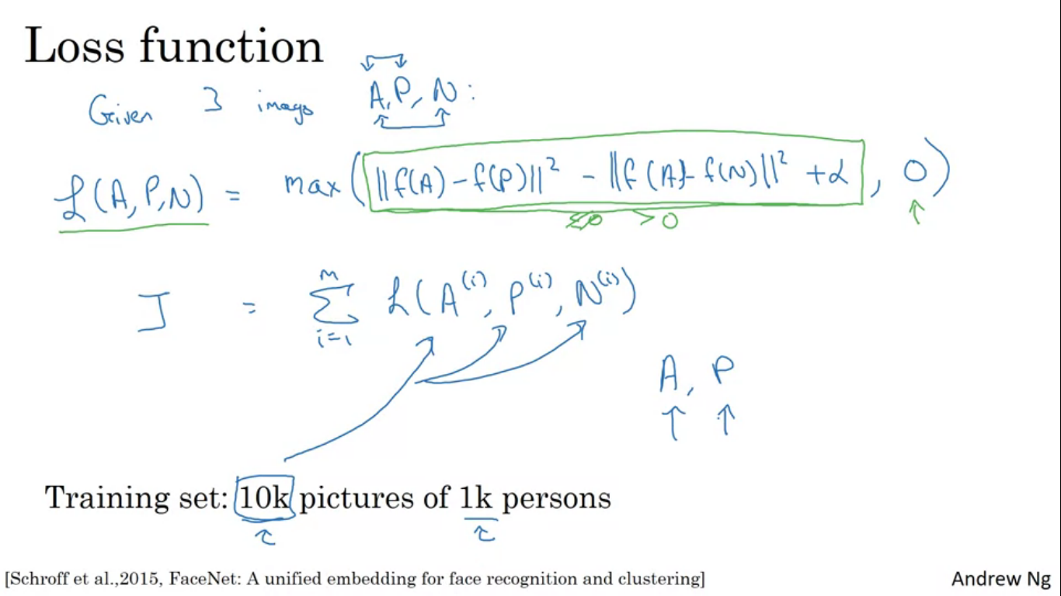

Effect of taking the max here is that as long as the equation is < 0 then the loss is zero. On the other hand if the equation is > 0 the max will end up selecting the value from equation and we would have a positive loss. The L is the loss function on a single triplet, overall cost function for the NN is represented by J.

If you have 10000 pictures of a 1000 persons we use it generate triplets and then train the learning algorithm using GD on this type of cost function. To define these triplets of same person we need some pairs of A and P. So if we have just 1 picture per person we can’t actually train this system.

**How to choose these triplets to form your training set?**

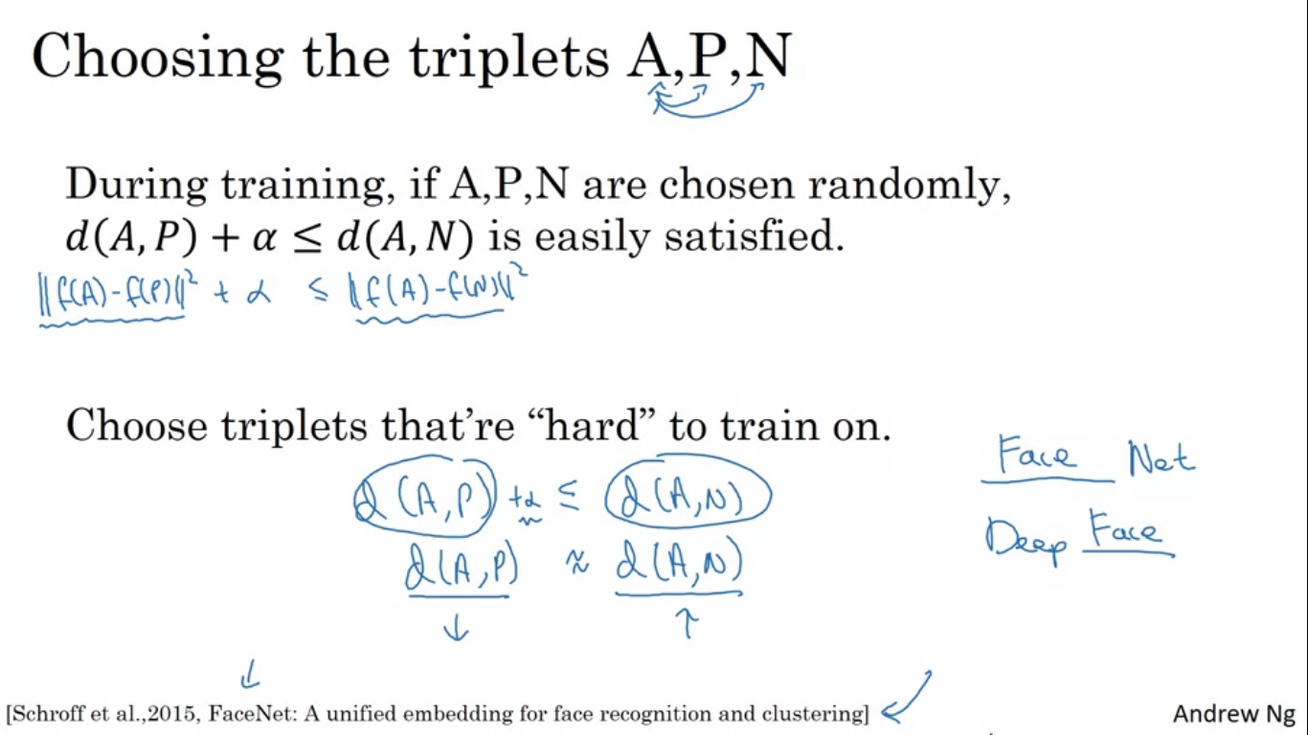

If you choose at random from the training set subject to A and P being the same person and A and N being the different persons, if we choose at random then the criteria is very easy to satisfy. Given two randomly chosen pictures of people, chances are A and N are much different than A and P, so NN won’t learn much from it. To construct the training set we want to choose the values A, P, N that are hard to train on. Triplets that are hard to train on are actually the ones d(A,P) is actually very close to d(A,N). In that case the NN has to work extra hard to satisfy the criteria. Effect of choosing this triplet is that it increases the computational efficiency of the learning algorithm.

**Face verification and binary classification**

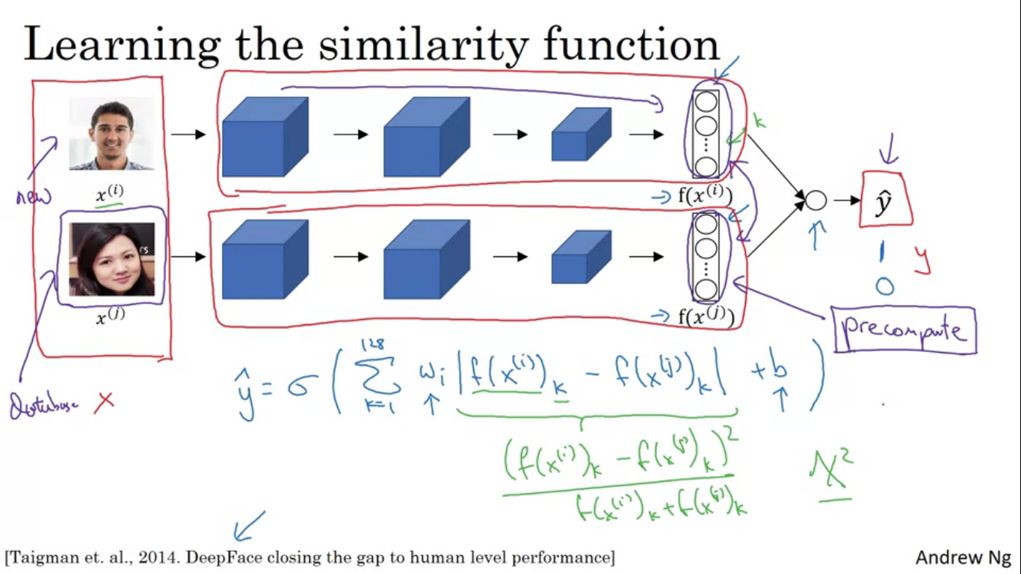

Face recognition as a binary classification problem. Take the Siamese networks and have them both compute the embeddings maybe 128 dimensional embeddings and then these be input to a logistic regression unit to then make a prediction where the target output will be 1 if both the images are of the same person and 0 if both the images are of a different person.

The output yhat will be a sigmoid function applied to some set of features. But rather than just feeding in these encodings , we take the difference between these encodings. F(xi) is the encoding of the image xi, and the subscript k is for the kth component of this vector. The equation is taking the element wise difference in absolute values between these two encodings.

For a live demo we can have the feature vector of anchor pre computed so that we can compute the feature vector of the positive image and then quickly compare if the image/ person is really positive or negative.

Training set of pairs of images with target label as 1 or 0. 1 for same and 0 for different.

**Neural Style Transfer**

We take an image called content image and we want the picture recreated in the style of right image. Notation S – style image, C – content Image, G – Generated Image.

In order to generate Neural Style Transfer, you need to look at features extracted by conv net at various layers.

**What are deep conv nets really learning?**

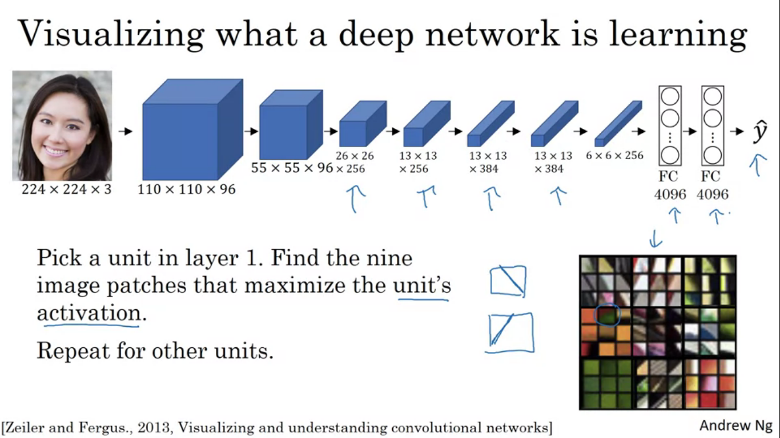

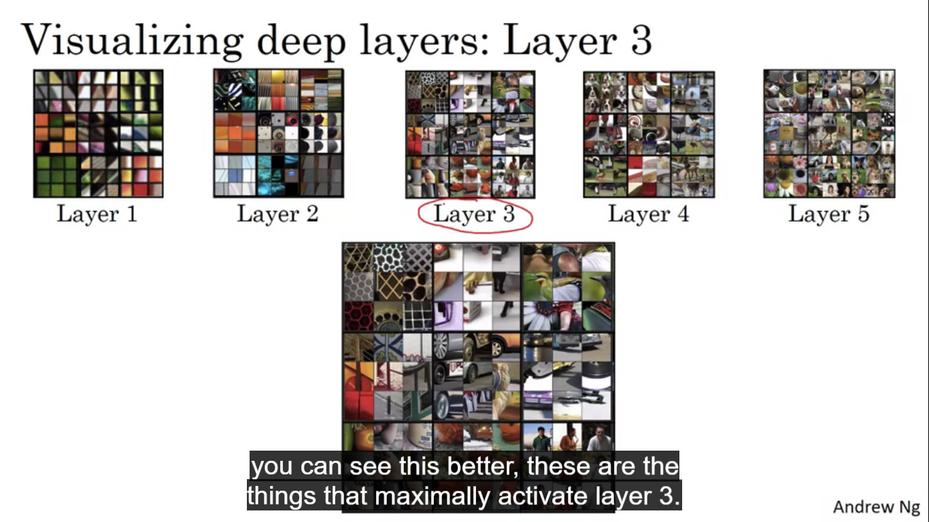

We want to visualise what the hidden units in different layers are computing. You scan through the training set and find out what are the image patches that maximize that unit’s activation. We pass the training set through our NN and figure out what is the image that maximizes that particular unit’s activation. A hidden unit in layer 1 will only see relatively small portion of the NN. So if you pick one hidden unit and find the nine input images that maximizes that unit’s activation we find nine image patches like shown. Those are nine image patches that maximally activate one hidden unit’s activation. Different hidden units tend to activate in different image patches. Hidden units in layer 1 are often looking for relatively simple features such as an edge or a particular shade of colour. This was done for nine units in layer 1, what if we did this for some of the hidden units in deeper layers of NN. In deeper layers the hidden unit will see a larger region of the image where each pixel could affect the output of these later layers of the NN. Each of them is the nine patches that caused one hidden units to be highly activated. So the visualisation shows nine hidden units and for each of the hidden units shows nine image patches that causes the hidden unit to have a vaery large activation.

**Cost function**

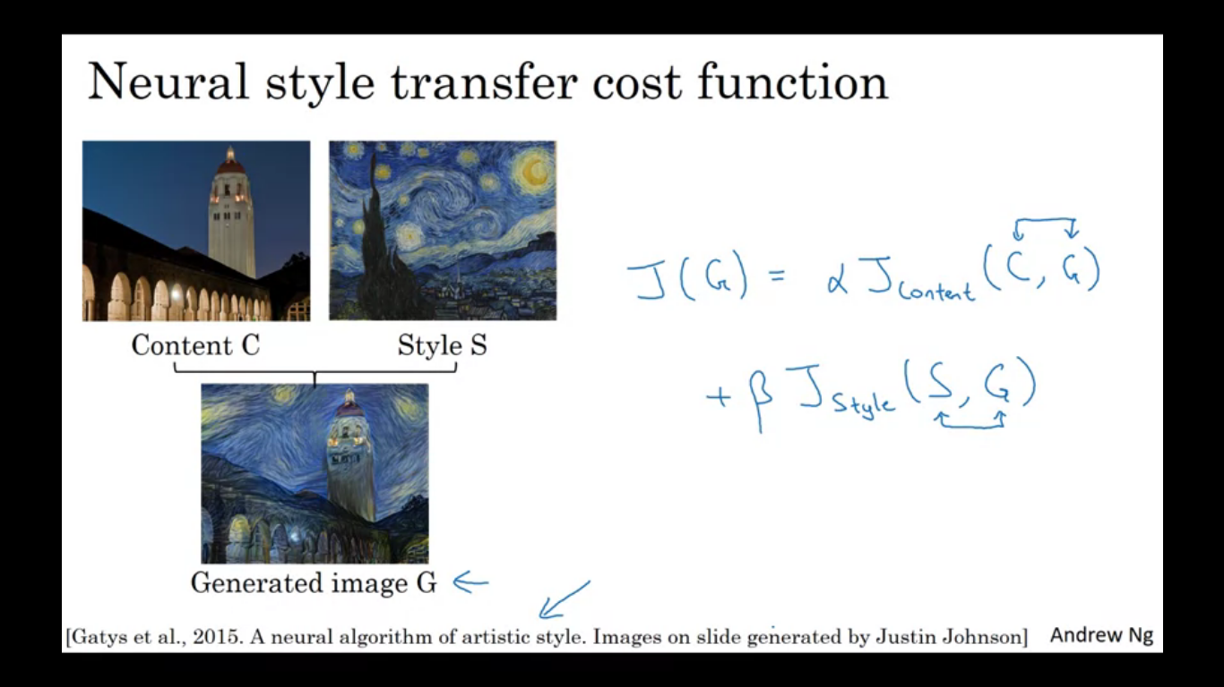

To build a Neural Style Transfer System, let’s define a cost function for the generated image. By minimising this cost function we can generate the image that we want. The cost function J(G) measures how good is a particular generated image and we use GD to minimise J(G) to generate this image.

We define two parts of this cost function, first part is called content cost, this is a function of content image and generated image. It measures how similar is the content of generated image is to the content of content image C. We add that to a style cost function which is a function of S,G. This measures how similar is the style of the Image G to the style of the style image S. Finally we weight these two hyper parameters alpha and beta to specify the relative weighting between the content costs and style cost.

After defining the cost function what we do is the following.

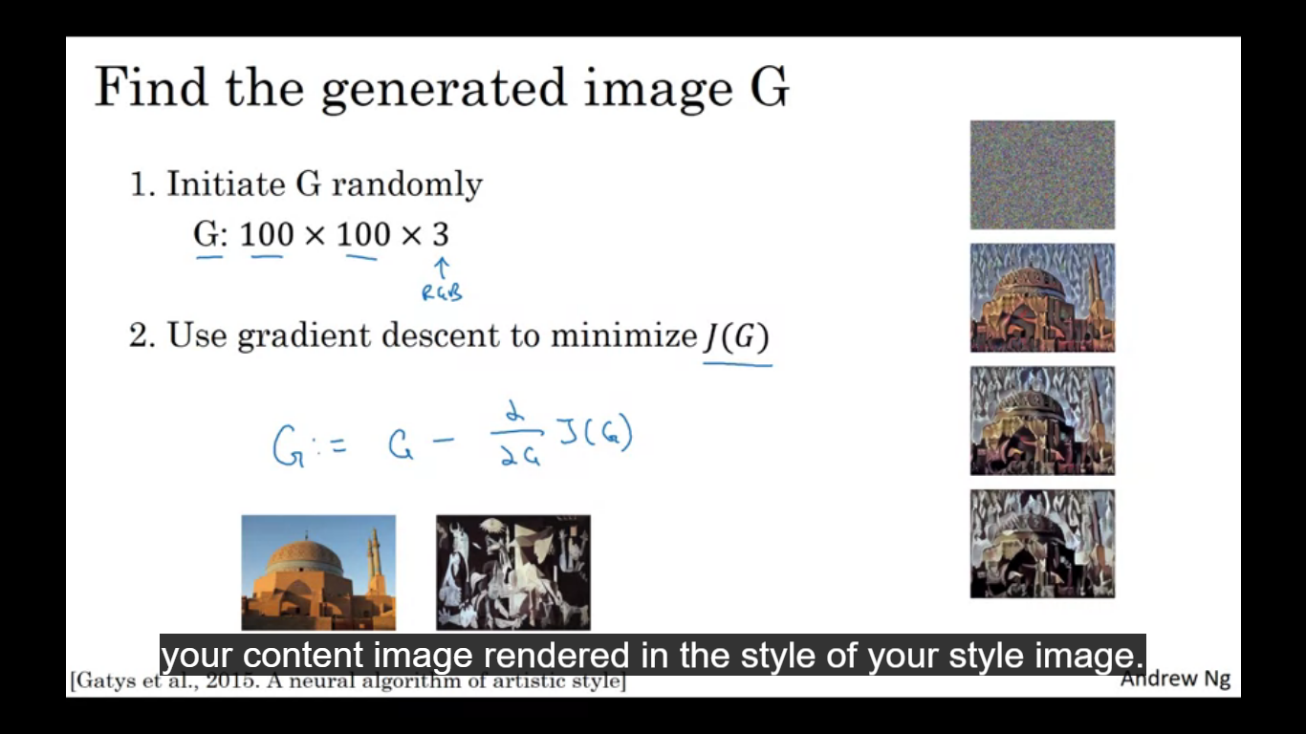

Initialise generated image G randomly G:100x100x3.

Then we define the cost function as previously and use GD to find out G. In this process we are actually updating the pixel values of this image G. Next we need to define content cost function as well as style cost function.

Content cost function

Overall cost function

**J(G) = alpha * Jcontent(C,G) + beta * Jstyle(S,G)**

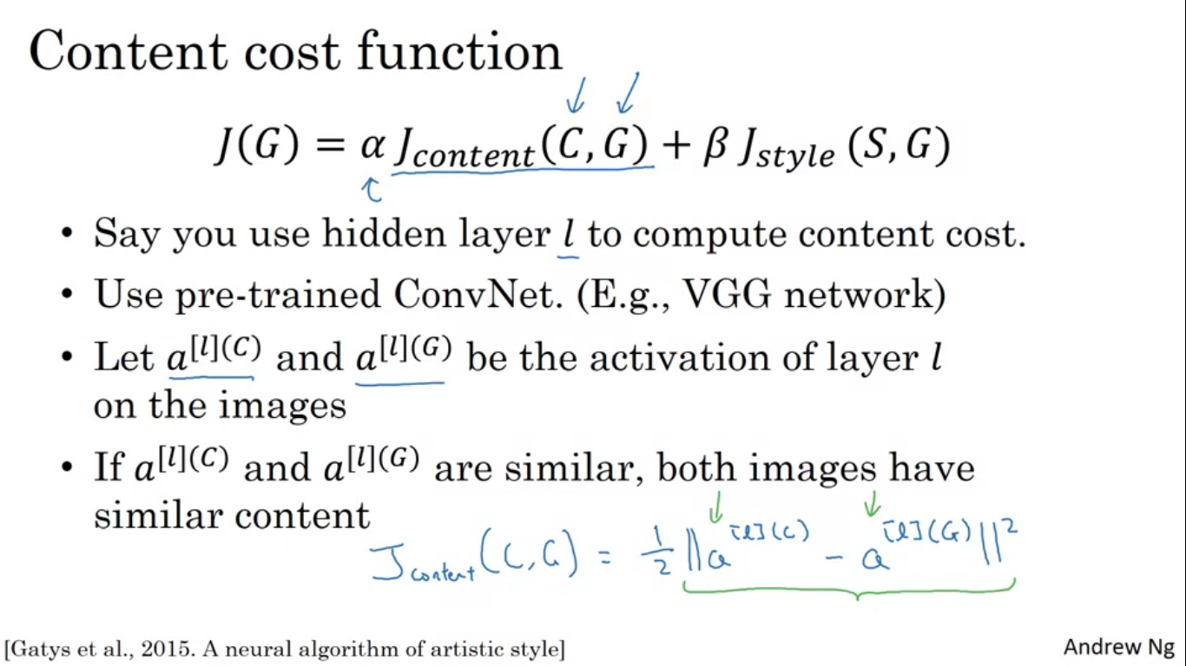

We use the hidden layer L to compute the content cost. If l=1 then it will really force your generated image to have pixel values very similar to content image. Whereas if we use a very deep layer then it is just asking if there is a dog in the content image then make sure there is a dog somewhere inyour generated image. In practice layer l chosen is somewhere in between. Neither too shallow nor too deep in the NN , chosen to be in the middle of the NN.

We then use a pretrained conv net. We want to measure how similar are the content and generated image in content? We define the activations (vectors) of layer l on these two images. If the two activations are similar then both images have similar content. So Jcontent(C,G) is the element wise difference between the hidden units activation in layer L. When later we perform GD on J(G) to find the value of G so that the overall cost is low, this will intensify the algorithm to find an image G so that these hidden layer activations are similar to what you got for the content images.

**Style Cost function**

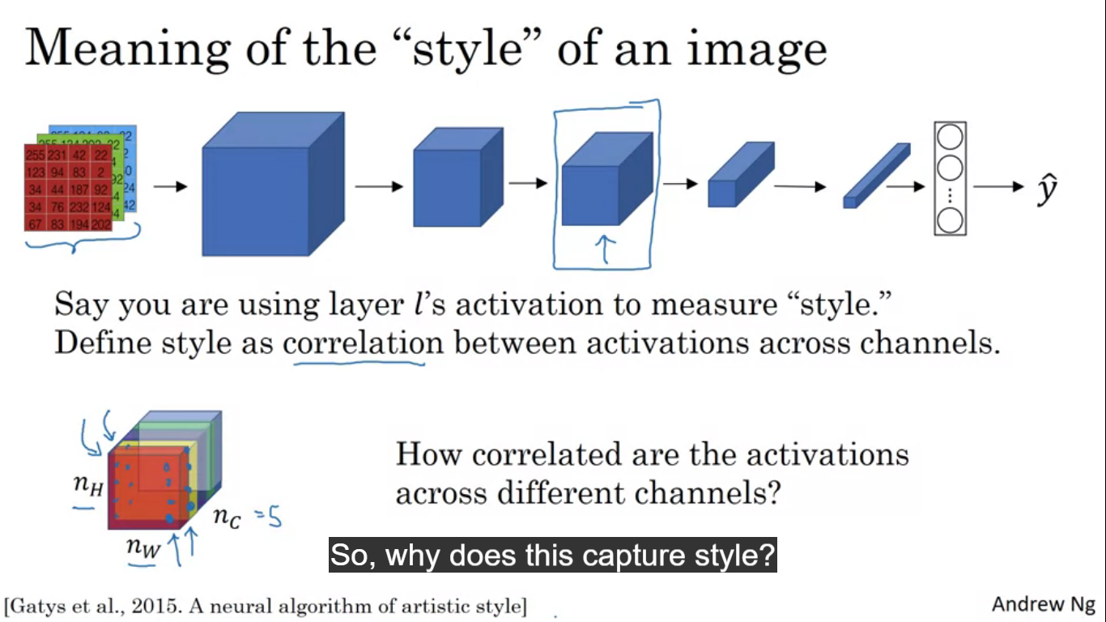

We define style as the correlation between activations across different channels in this layer L activation. If we take a layer then it is going to be nhxnwxnc block of activation and we ask how correlated are the activations across different channels? Let in the example shown we have 5 channels. To capture the style of an image let’s look at the red and yellow channel and ask how correlated are activations in these two channels. So we have some activation in the first channel and some activation in the second channel. What we do is to look at different positions across this block of activations and look at the pair of numbers one in the first channel and one in the second and see how correlated are these two numbers.

**What does it mean for the two channels to be highly correlated?**

Wherever there is this vertical texture that part of image will probably have these orange-ish tints. And for uncorrelated is wherever is the vertical texture it won’t have that orange-ish tint. Correlation tells us which of these high level texture components tend to occur or not occur together. Degree of correlation gives us a one way of measuring how often they occur together and not together.

If we use the degree of correlation between channels as a measure of style, what we can do is to measure the degree to which in your generated image the first channel is correlated or uncorrelated to the second channel. This will tell us how similar is the style of the generated image is to the style of an input style image.

Given an image, we compute something called as a style matrix which measures correlations.

So a[l]I,J,K denote activation at position I,J,K in the hidden layer l. I is for height, J is for width and K is for channels. G[l] will be an ncxnc dimensional matrix. We have nc channels so we have ncxnc dimensional matrix in order to measure how correlated each pair of them is.

So G[l]KK~ computes how correlated the activations are in channel K in comparison to channel K~. K and K~ varies from 1 to nc. To calculate G we have the formula. The formula sums over the different positions in the image over the height and width and just multiplying the activations together of channels K and K~. G is also called the style matrix. So if correlated then GKK~ will be large and if uncorrelated then GKK~ will be small.

We do this for both the style image S and generated image . G in linear algebra are also calle the gram matrix.

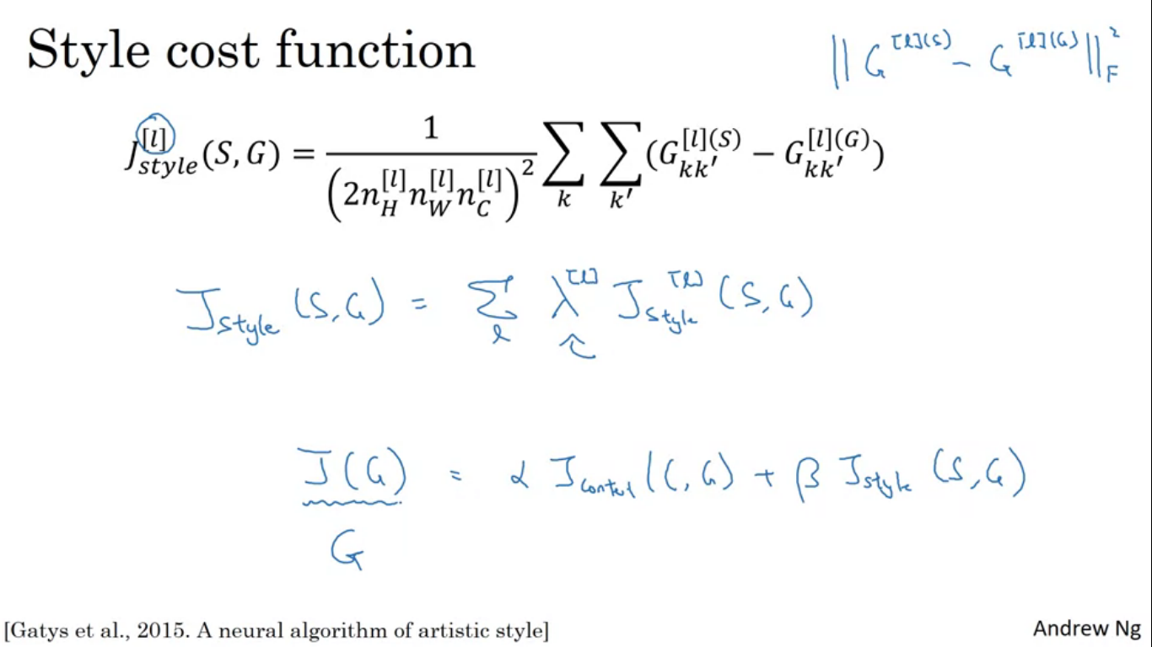

Finally the style cost function is the difference between these two gram matrices which is the sum of squares of element wise differences between these two matrices. the normalization does not mater much because this cost is multiplied by a hyper parameter beta. The calculation is frobenius norm over the style matrices computed on image S and generated image G.

We get better results if we use style cost function from multiple different layers. So we get the formula as shown. It allows the use of earlier layers which measure the simpler low level features and some later layers which measures high level features so we can take both into account while computing style.

**1D and 3D generalizations**

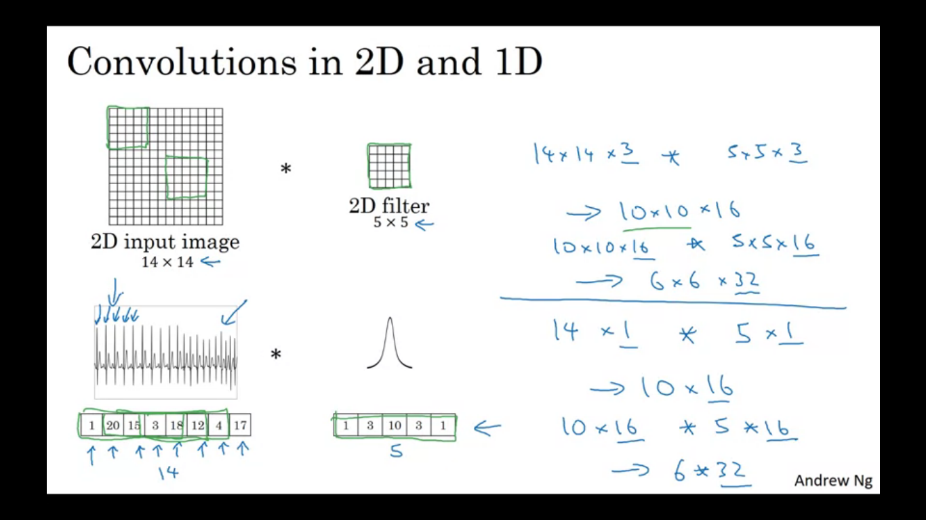

The ideas learned not only apply to just 2D images but also 1D data and 3D data. For 1D data, example EKG is a time series showing the voltage at each instant in time. So rather than 14x14 dimensional input we just have a 14 dimensional input. In that case we convolve it with a 1D filter by applying it to the filters throughout the 1D channel. 14 dimensional thing convolved with 5 dimensional thing gives 10 dimensional output.

Ct scan is 3D data. Movie slices are 3D data where different slices are different slices in time through a movie.

